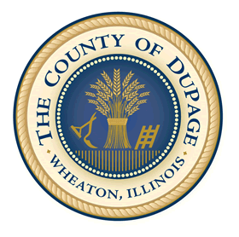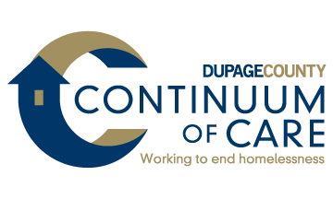

DuPage County Homeless Management Information System
This posting summarizes how information about you may be used and disclosed and how you can get access to this information.
Agency use of your information | - We collect personal information for reasons that are discussed in our Privacy Notice.  - We may be required to collect some personal information by law or by organizations that give us money to operate this program.  - Other personal information that we collect is important to run our programs, to improve services, and to better understand the need individuals in the community.  - We only collect information that we consider to be appropriate.  - We assume that you consent to the use or disclosure of your personal information as described in the Privacy Notice.
Your rights and choices | - You have the right to request a copy of the Privacy Notice and have your questions answered.  - You have the right to refuse to answer any question we ask, though this may impair our ability to provide the services you are requesting.  - You have the right to opt-out of having your information shared with other agencies by requesting and signing the “Client Data Sharing Refusal Form.”
Contact information | [Agency Contact Info] | DuPage County HMIS System Administrator 421 N County Farm Road  Room 3-100  Wheaton, IL 60187 www.dupageco.org/HMIS  630-407-6397

To read the full Privacy Notice, ask for a copy or visit [Agency Website]

