Safety Planning
Safety Planning is an important part of working with somebody who has experienced domestic violence. There is no safety plan where “one size fits all”. Everybody’s situation is different. Tailoring a safety plan to each individual’s situation is important. The following ideas are some basic steps that can help you, help a domestic violence survivor;
Before an attack:
- Practice how to get out of the house safely. Which door, elevators, stairwells or fire escapes can be used?
- Decide where to go if you have to leave home.
- Prepare an overnight bag. Keep it in a readily accessible place. In addition to clothes, include in it:
-Money, checkbook, credit and debit cards, ATM cards
-Driver’s license and registration, social security cards, birth certificates.
-Public Aid cards, green card, passports, work permits.
-Order of Protection, divorce papers.
-Medications, medical and vaccination records.
-Lease, rental agreement, house deed.
-Keys to house, car, and work.
-Insurance information.
-Address book.
- Leave a set of keys and copies of important documents with a neighbor or trusted friend in case you need to leave quickly and your bag is not accessible.
- Tell a neighbor about the abuse and ask them to call the police if they hear any suspicious noises coming from the house.
- Develop a code word with the children and friends to signal them to call the police.
- Teach these strategies to the children.
During an attack:
- Move to a room that is lowest risk with easy access to an exit. Stay away from enclosed spaces near any weapons, such as the bathroom, kitchen or garage.
- Get away. Go to a friend’s or relative’s house.
- Call 911. They are required to provide or arrange transportation to a hospital or safe place for you.
- Call for help. Scream loudly and continuously.
After an attack:
- Get medical attention immediately. Tell the doctor or nurse what happened. Ask them to take pictures of your injuries.
- Make a police report, even if you don’t want the abuser to be arrested. It will be a record of the incident and will provide evidence if you ever need it. The abuser will not be notified that you made the report.
- Save evidence, including medical records, police reports, dated photos of your injuries or the house in disarray, torn clothing and any weapons used.
- Call Family Shelter Service’s 24 hour hotline at 630-469-5650 for support and services.

While preparing to leave, it must be done with the utmost care. Gathering documents and making copies of them must be done without the knowledge of the abuser. Remember, the most dangerous time for a DV survivor is when they attempt to leave.

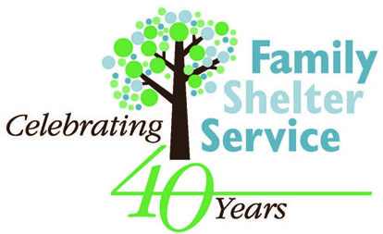Healing from Domestic Abuse
605 E Roosevelt Road, Wheaton, IL 60187 (630) 221-8290
24 hour-Hotline (630) 469-5650

