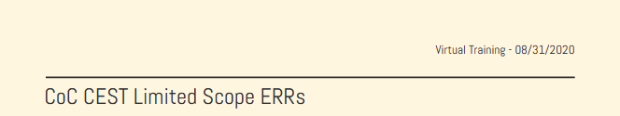
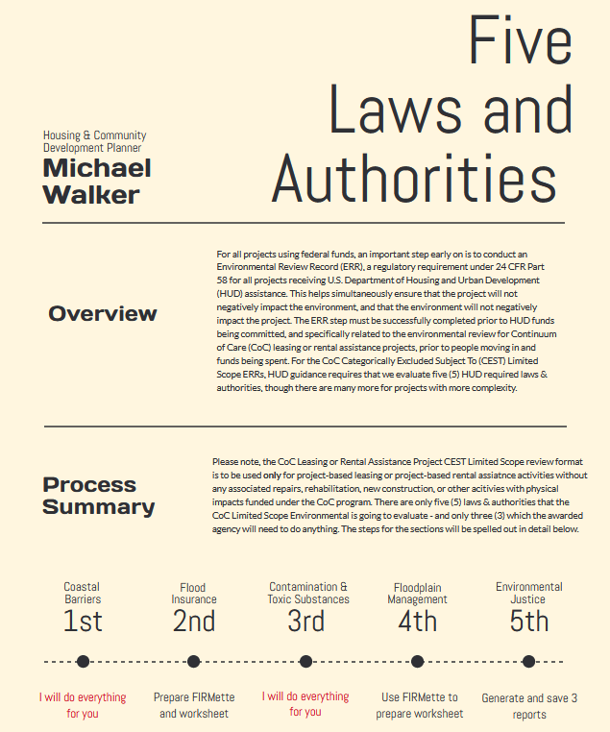

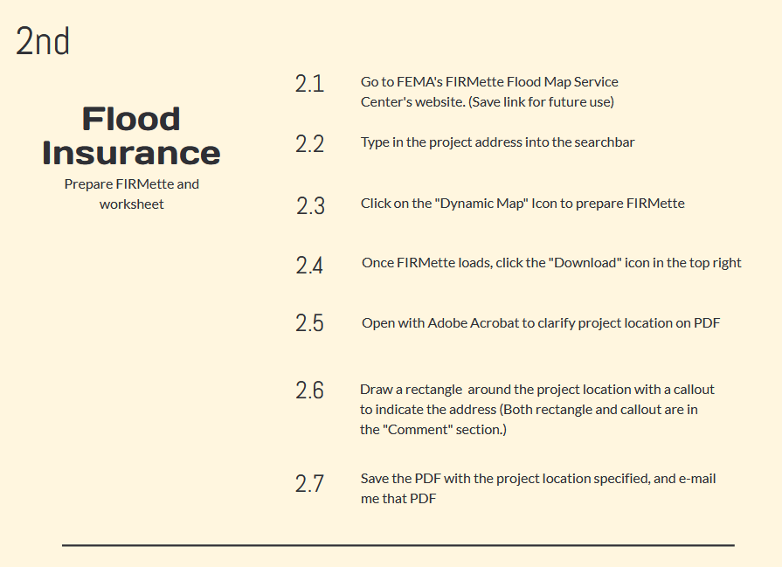

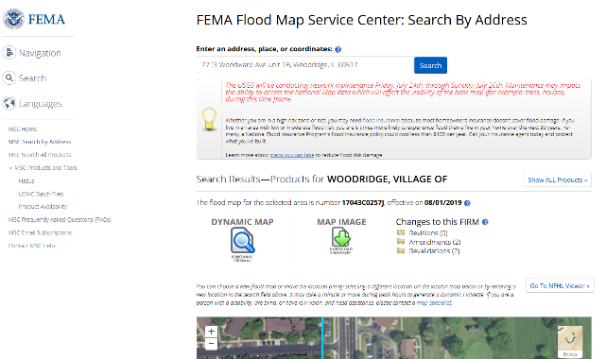

Go to: https://msc.fema.gov/portal/search

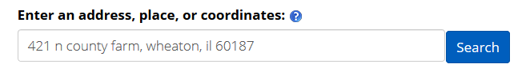
Type in project address

Click on Dynamic Map
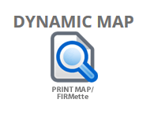

Click on the FIRMette’s download icon
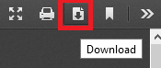
Open with Adobe Acrobat to clarify project location
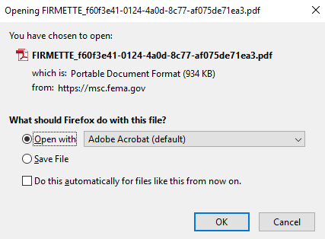

Draw rectangle around project location, and a callout for the address
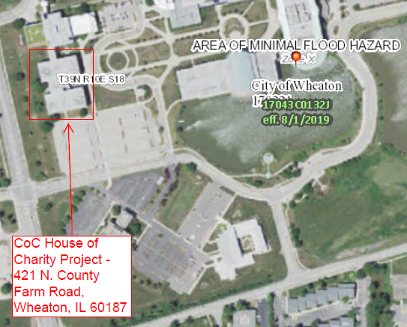

Save the marked PDF and send it to me @ michael.walker@dupageco.org

With the FIRMette completed, now use this document to complete both the
2. Flood Insurance and 4. Floodplain Management worksheets.
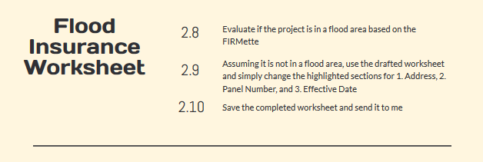

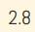 Evaluate if the project is in a flood area based on the FIRMette. If the map does not clearly show colored-in sections of flood area, it is likely not in a flood area, but if you are unsure, please simply send me the FIRMette; if the project is not in a flood area, then continue.
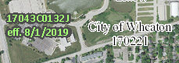
Take the drafted worksheet and change the three highlighted sections. The effective date will be in green with a black border (with “eff.” by it) and the panel number will be in black with a white border.

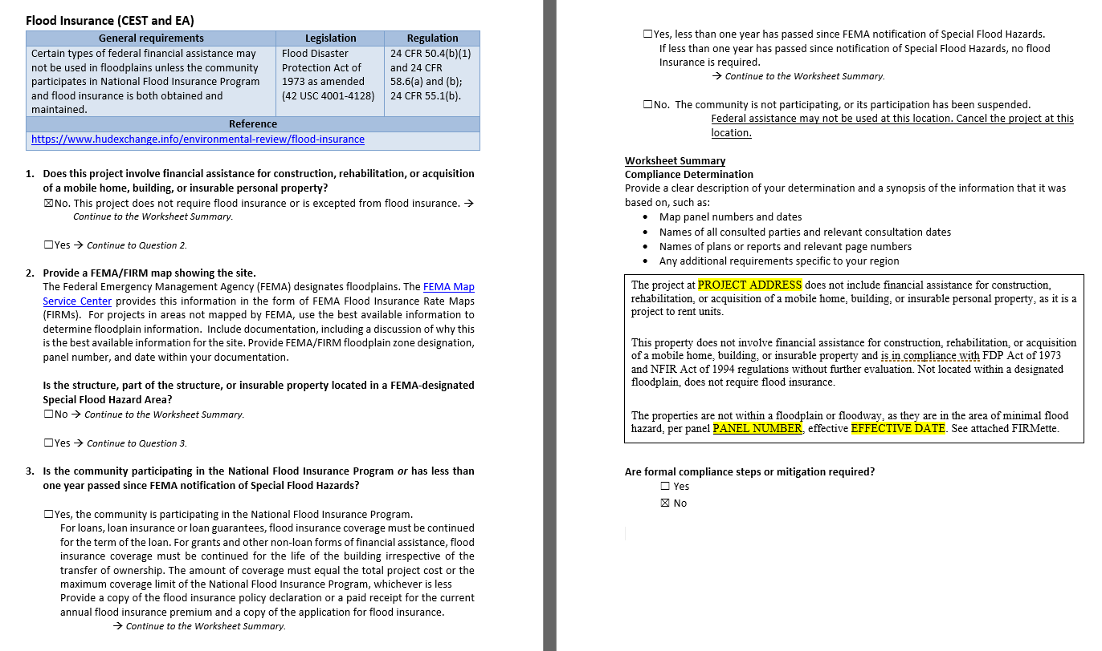

Save the completed worksheet and send it to me with the rest of your CoC ERR documents @ michael.walker@dupageco.org

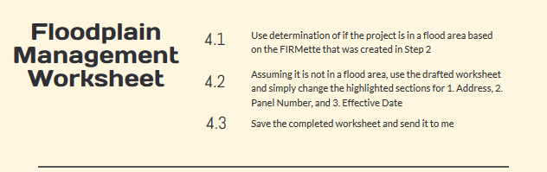

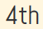

Using the same determination that was concluded from Section 2, use the FIRMette to show that the project location is not within a flood area; again, if it is or if you are unsure from the FIRMette, please ask me.

Most projects are not, and if this is the case, change the highlighted items for this worksheet similar to the one from Section 2.
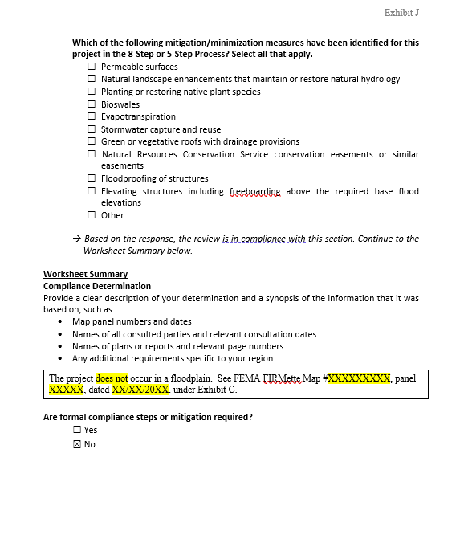
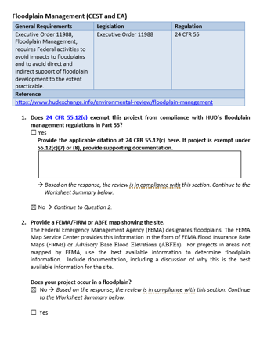

Save the completed worksheet and send it to me with the rest of your CoC ERR documents @ michael.walker@dupageco.org

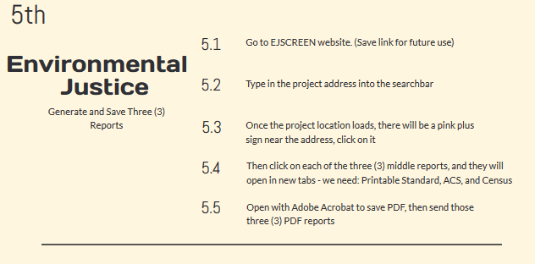

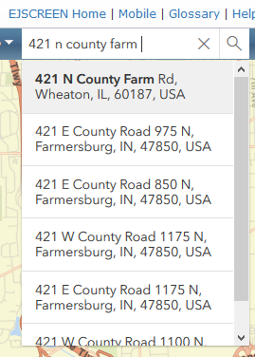
Visit the EJSCREEN website at: https://ejscreen.epa.gov/mapper/index.html?

Type project address into the searchbar

Once project location loads, click on pink plus
Clicking the pink plus sign will show reports
Click on the three center reports; namely:
Printable Standard, ACS, and Census – these will open
In new tabs.
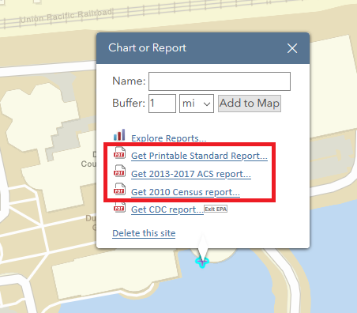
Open and save all three (3) PDFS, and then
send those to michael.walker@dupageco.org
with the rest of your CoC ERR items.

Now that you have all your documents, please send me all of these for review:
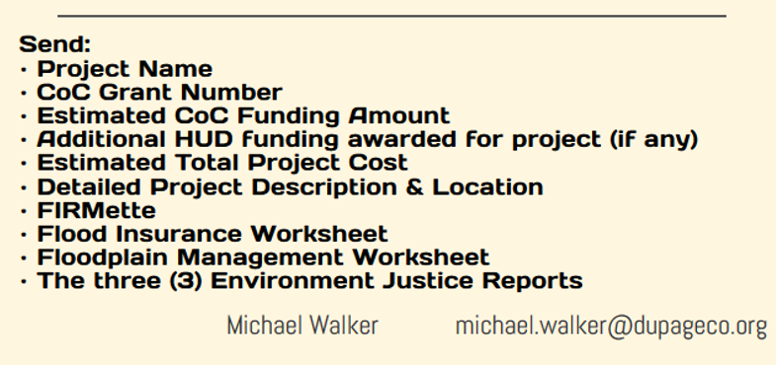

If you have any questions along the way, feel free to ask – I am here to help.

